**LEADS BD**

***(Website content)***

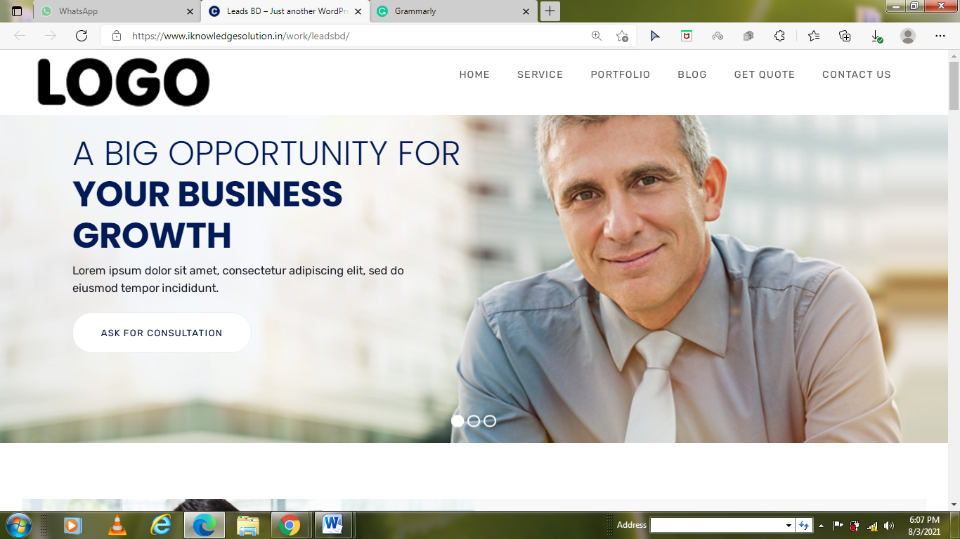

**A BIG OPPORTUNITY FOR YOUR BUSINESS GROWTH**

Ready to optimize your sales with our quality leads? Lead BD offers you tremendous opportunity for business growth by providing quality leads that convert.

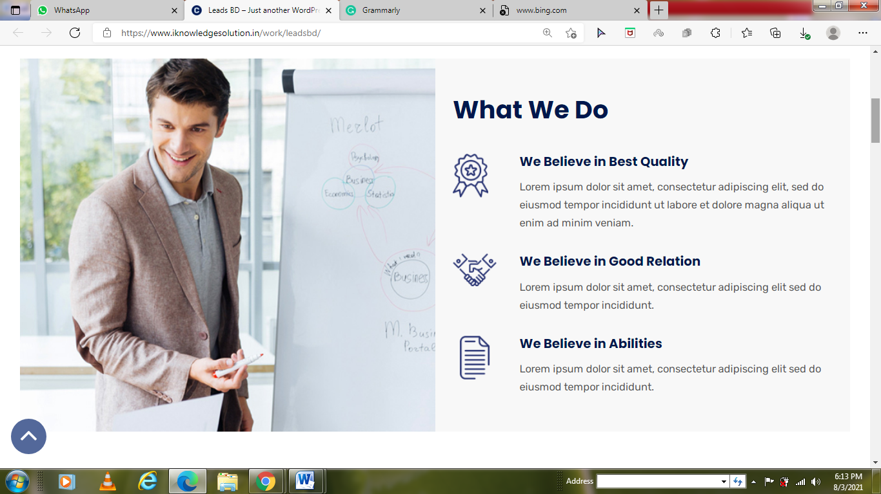

**What We Do?**

We fill the pipeline with high quality leads that converts

***Generate Genuine Leads***

No more time wasting in poorly qualified leads. We introspect and filter leads before passing to you so focus on growing your business.

***Help Grow your Brand***

The brand comes before anything and everything. Our experts will premium lead generation tools like LinkedIn sales navigator and email hunters to get you all the details of your target audience.

***Nurturing Relationships***

We work remote but always try to reach out to our valuable clients via our unmatchable services. With our highly-converting leads, our clients are sure to come back again and again to us.

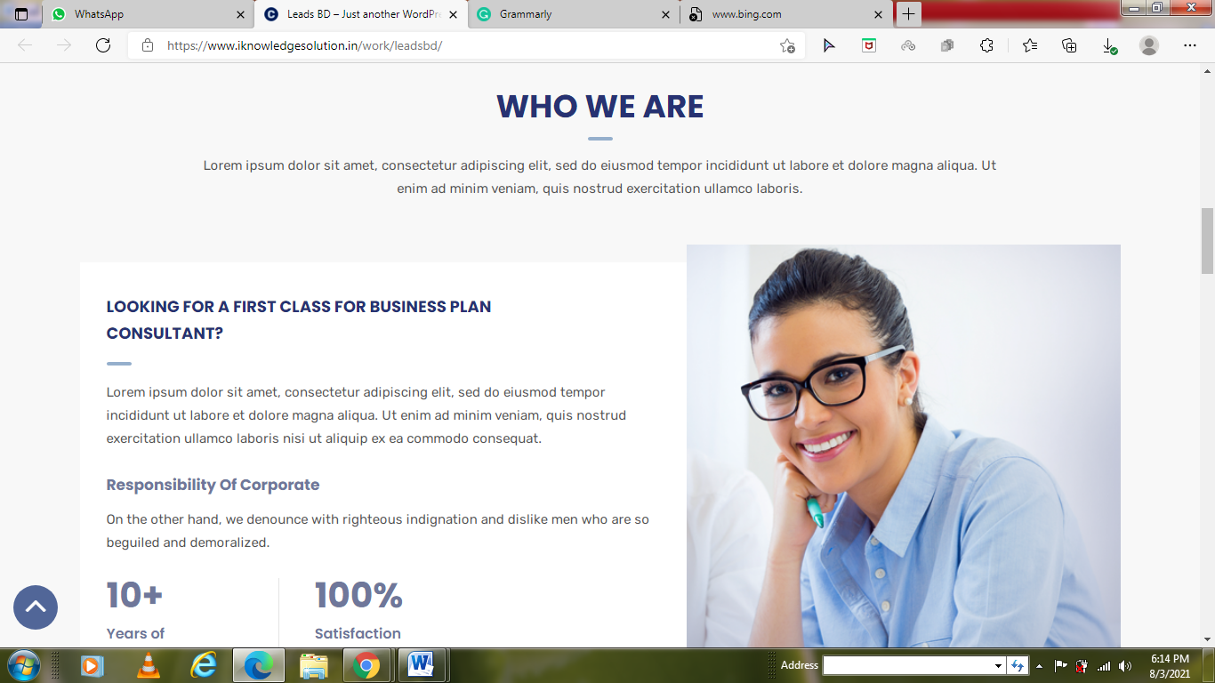

**Who We Are**

We are lead generation experts with international experience and expertise that helps you find high-quality, genuine leads for your business and will leave no stone unturned to drive your success.

***Our Methodology***

We believe every business has a unique value and sales potential; it is all about how you unlock it. Through our hard work, hands-on technology, and tailored lead generation solutions, we will do it for you.

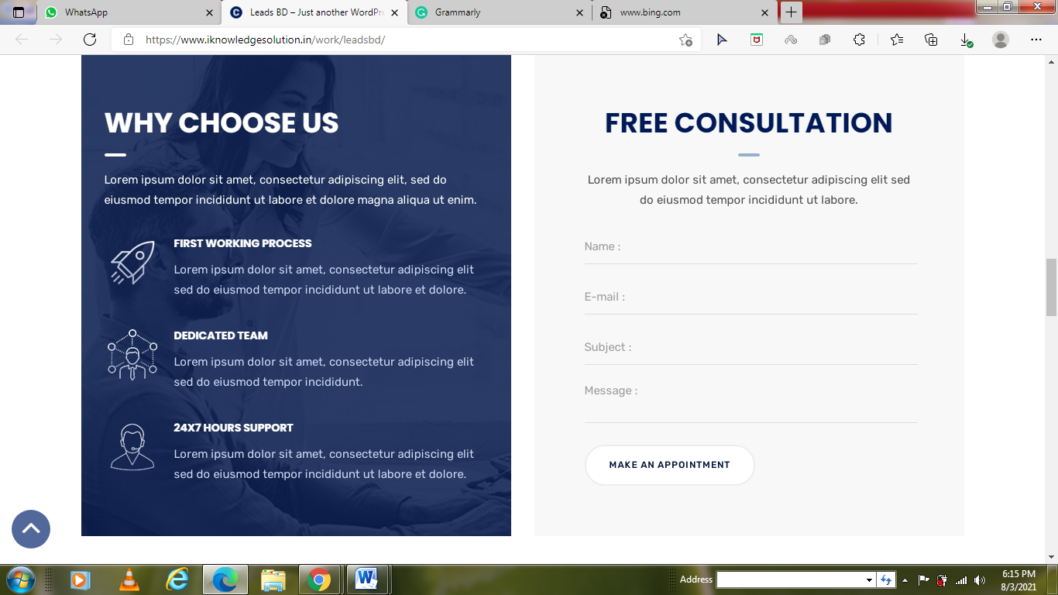

**Why Choose Us**

We create opportunities so you could close the deals.

***Fast Working Process***

At Leads BD, time is real essence. As soon as our clients reach out to us about any target, our lead generation experts do their thing and provide our clients with email list containing all the asked for information.

***Dedicated Team***

To serve your real business to success, you need real people with right skills and true dedication. Our dynamic lead generation team is ready to put their 100% into your business. Are you?

***24/7 Support Service***

Being a globally remote team, we utilize range of latest technologies to be available seamlessly and deliver excellent lead generation services in a more efficient way.